Contents

ORM 3

Entity Framework Core 6.x 3

Course Link 3

Nuget Packages 4

In Data Access 4

In Web tier 4

Make Migrations 4

Primary Key Set 4

Required properties 4

Snapshot File 4

Remove Migration or Update existing Table. 4

Remove a table 4

Roll back to old migration 4

More Commands 5

Seed Data 5

Data annotations 5

EF Core Power Tools 5

Relations in EF Core 7

One to One 7

One To Many 7

Many to Many automatic 8

Many to Many creating intermediate table. 8

Fluent API 9

Common Commands 9

One to One Relationship 10

One To Many Relation 10

Many To Many Relation 11

Organizing Fluent API 12

ApplicationDbContext utilities 12

Database.EnsureCreated() 12

Database.GetPendingMigrations() 12

UseSqlServer(sqlConnectionString).LogTo(path) 13

Link Single(u=> u.Id == id) 13

EF.Functions 13

Pagination query sql server 13

Configure DbContext in Web Application 13

Create seed data with add migration. 14

Sql command executed log with Web application. 14

Projections in EF Core (Convert data types) 15

Load Complex object 15

Eager loading (Loading sub objects) 15

Deferred execution (When sql queries are executed) 16

IEnumerable vs IQueryable in EF core 16

Update vs Attach 17

Lazy Loading 17

Change Tracking 18

No changes tracking 18

Attaching views and store procedures 18

Views 18

Sql Raw (sql commads) 19

Store procedure 19

Returns from View or Store procedure 19

Command for Database First 19

# ORM

Object relational mapper. It is a technique that lets you query and manipulate data from database using an object-oriented-programing paradigm.

# Entity Framework Core 6.x

It is the new version of entity framework. It helps us to bring models from database and vice versa.

# Course Link

<https://dotnetmastery.com/Home/Details?courseId=11>

<https://github.com/bhrugen/CodingWiki_EF>

# Nuget Packages

## In Data Access

Microsoft.EntityFrameworkCore.SqlServer, this one include Microsoft.EntityFrameworkCore (the main one)

Microsoft.EntityFrameworkCore.Tools, this include Microsoft.EntityFrameworkCore.Desing

## In Web tier

Microsoft.EntityFrameworkCore.Desing

# Make Migrations

Make sure of **start project** and **default project.**

1. Set dataAccess start project
2. Command “**add-migration**” + a tag name example “CreatingBookTable”
3. Command “**Update-Database**” to create all object in the migration

## Primary Key Set

1. If the table only has one integer property with name ID
2. with [Key]
3. If the table only has one integer property THAT ENDS IN ID

## Required properties

If we do not put a property nullable It will assume that property as required

## Snapshot File

It has information about all migrations made.

# Remove Migration or Update existing Table.

It is recommend for non-updated migrations “**remove-migration**”

## Remove a table

Remove the dataset from dbcontext

## Roll back to old migration

Using “Update-Database” + the migration .cs file without date part of the name.

example “**Update-Database creatingBookTable**”

Then Just type “**Update-Database**” to applicate all migrations to database

# More Commands

1. **Get-migration** show up all migrations in console
2. **Drop-database** drop the database that is in connection string

# Seed Data

Create data and attach it to .HasData(), then add-migration

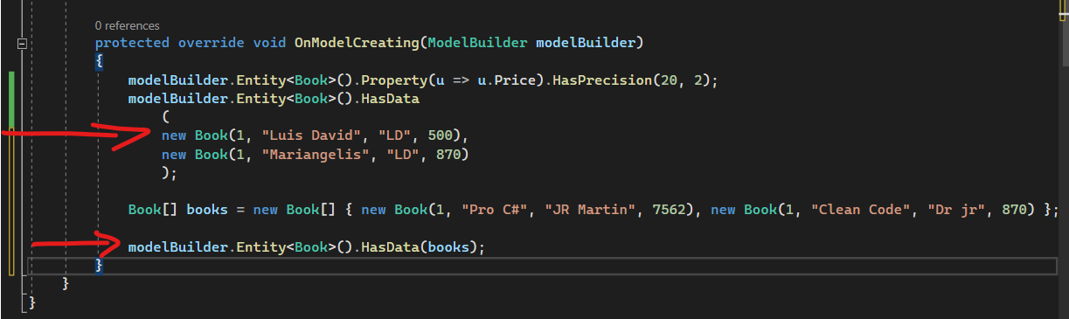

# Data annotations

1. Table name **[Table(“tb_Category”)]**
2. Column name **[Column(“tb_Category”)]**
3. **[Required]** put some column required.
4. **[Key]** put primary key.
5. **[MaxLength(50)]** varchar(50)
6. **[NotMapped]** It property is not added as new column
7. **[ForeignKey(“PropertyName from base foreign key table”)]**

# EF Core Power Tools

To create Table diagram in visual studio

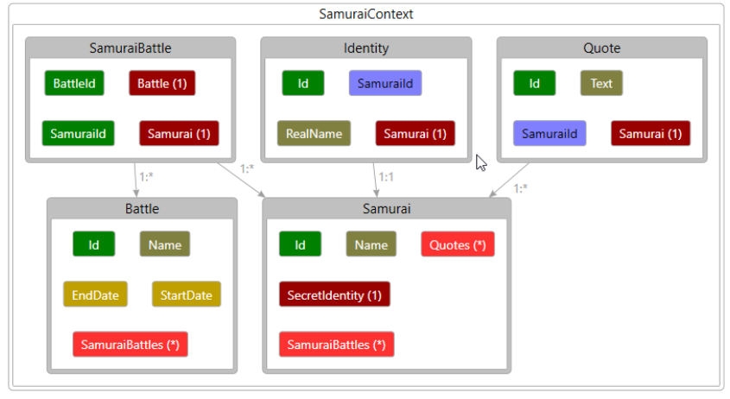

# Relations in EF Core

## One to One

Example BookDetail has a foreign key to Book.

1. Create a [ForeignKey(“Book”)] Book is the property name from the base table
2. Create property foreign key
3. Create property table base of foreign key
4. Create BookDetail property in Book

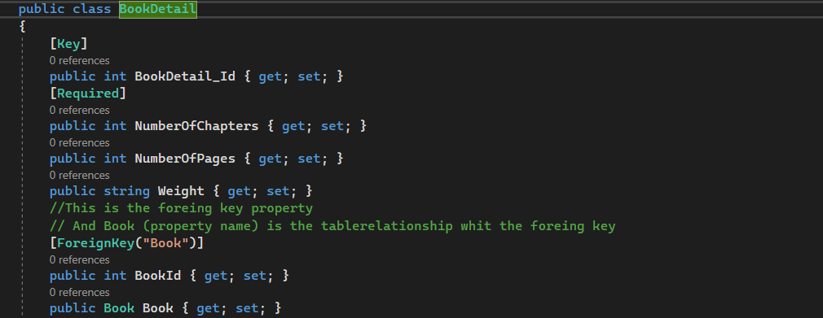

## One To Many

One **publisher** can have many **books**.

1. **Publisher_Id** and Publisher **navigation** property in Book
2. **List<Book>** in Publisher, because One publisher can have many books

**Book Entity**

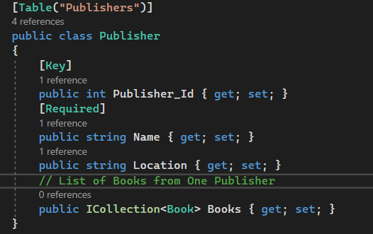

## Many to Many automatic

One **Book** can have multiples **Authors**. One Author can have multiples Books.

1. List of Book in Author
2. List of Author in Book

EF Core 6.x Create an **intermediate table** itself.

## Many to Many creating intermediate table.

1. Create BookAuthor Table with bookId and authorId. And Author and Book references
2. Property virtual Icollection<BookAunthor> in Book
3. Property virtual Icollection<BookAunthor> in Author
4. Compose primary key in OnModelCreating

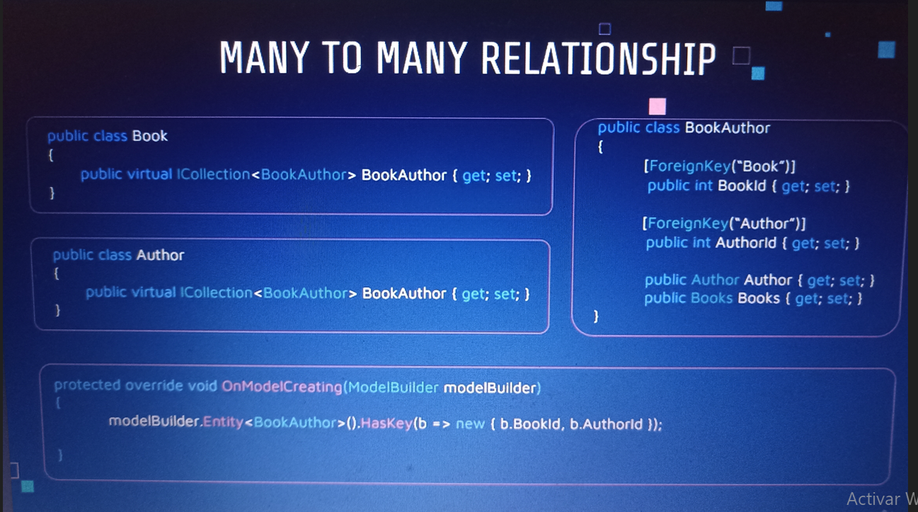

# Fluent API

Fluent API is an advanced way of specifying model configuration that covers everything that data annotation can do in addition to some advanced configuration which are not possible with data annotation. It is in **OnModelCreating**.

## Common Commands

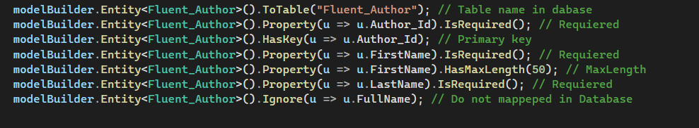

## One to One Relationship



Fluent_BookDetail

Fluent_Book



## One To Many Relation



Fluent_Book



Fluent_Publisher



## Many To Many Relation

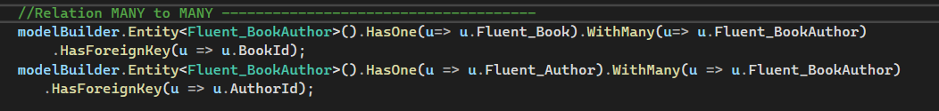

Fluent_BookAuthor

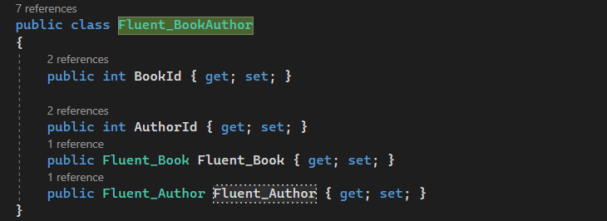

Fluent_Book



Fluent_Author



## Organizing Fluent API

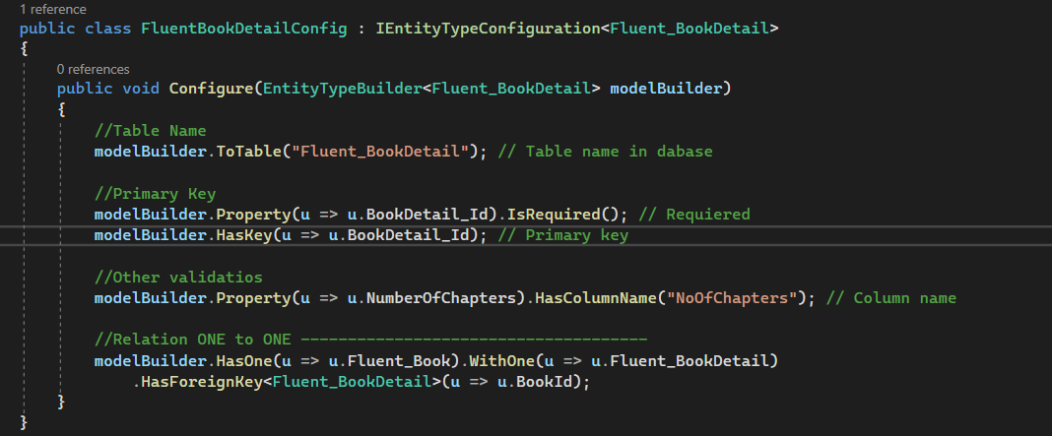

# ApplicationDbContext utilities

Database.EnsureCreated()

check if database is created in case of no, this command creates it



## Database.GetPendingMigrations()

Look for pending migrations

## UseSqlServer(sqlConnectionString).LogTo(path)

Show the sql commands executed by each one ApplicationDbContext action



Additional configuration for getting information about how is ef retrieving data



## Link Single(u=> u.Id == id)

If there is more than one throw an exception.

## EF.Functions

Like or another database functions

# Pagination query sql server

# Configure DbContext in Web Application

**Step 1:**  set connection string in application.json in **ConnectionStrings**  section



**Step 2:**  In program.cs

**Step 3:** In application Db Context

# Create seed data with add migration.

**Step 1**: add migration empty.

**Step 2**: Create data manually.

**Step 3**: update database

# Sql command executed log with Web application.

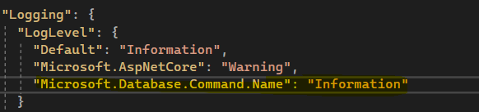

# Projections in EF Core (Convert data types)

Converting data

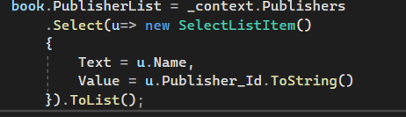

# Load Complex object

# Eager loading (Loading sub objects)

Populate all the sub objects in a model using same sql statement.

Ways to populate sub objects

1. Reserve word **Include** to include sub objects.(Most efficient, **just one query**)
2. Iterating books and adding **reference** for object or **Collection** for collections
3. Make all in one with **ThenInclude** to populate sub objects in the same line. (Most efficient, **just one query**)

**First way**





**Second way**

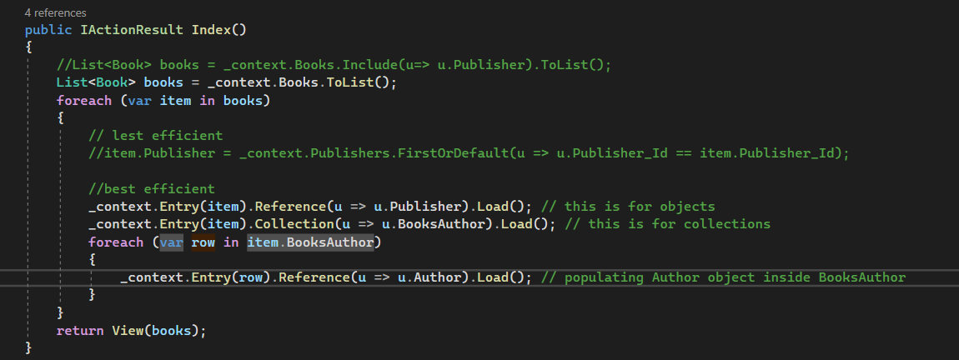

**Third way (All in one)**

# Deferred execution (When sql queries are executed)

Sql command are executed just when the code is usen it. Or when you put a ToList(), or access to object properties.

# IEnumerable vs IQueryable in EF core

**IEnumerable**: Return all records and then apply the filter.



**IQueryable**: excute the sql command with the where all time



# Update vs Attach

**Update**: Update the complete object

**Attach**: Just update the properties that have been changed.

# Lazy Loading

It is not recommend because it cost too much doing a lot of select statements

**Step 1**

From nuget package install Microsoft.EntityFrameworkCore.Proxies

**Step 2**

In Program.cs Use Lazy Loading Proxies

**Stept 3**

Make all the related navigation properties.

# Change Tracking

You can see object entities inside _context.

In watch write down _context.ChangeTracker.Entities()

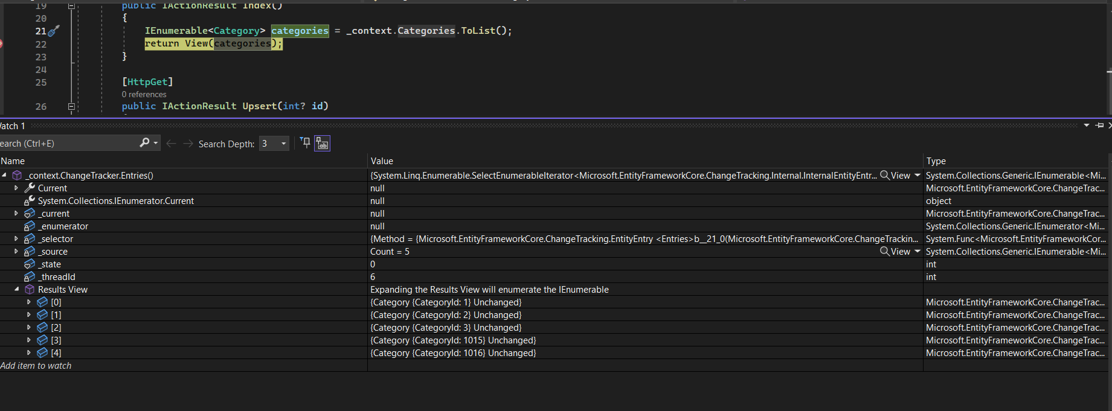

# No changes tracking

Adding AsNotTracking command, you cannot see _context Tracking in database (This options is faster than without this command)



# Attaching views and store procedures

## Views

1. Add an empty migration and create your view or store procedure.

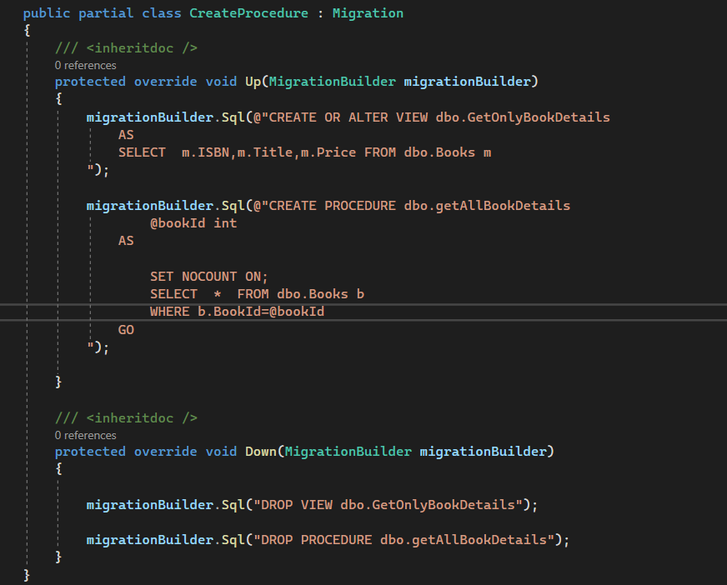

1. Create a model with the same number of parameters of the return view or procedure.
2. Add the new model to DbSet en applicationDbContext
3. In OnModelCreating add (image code) for not create a table in database



1. Just use this new model from your _context



## Sql Raw (sql commads)

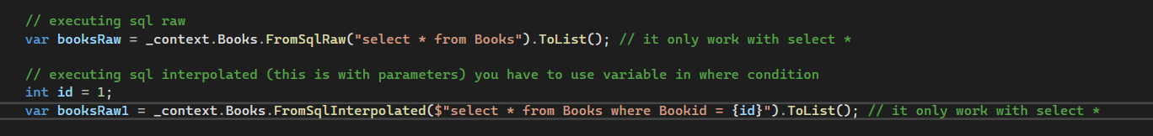

## Store procedure



## Returns from View or Store procedure

The store procedure number of columns should be equal to the model that is retriving

# Command for Database First

This command retrieve all tables in database and create it such as class inside your project.

Scaffold-DbContext "Data Source=DESKTOP-H20O12E;Initial Catalog=Northwind;Integrated Security=True" Microsoft.EntityFrameworkCore.SqlServer -OutputDir Models